JOHN A. GIUNCO, ESQ.  SHAREHOLDER  JGIUNCO@GHCLAW.COM  DIRECT DIAL: (732) 219-5496 | Please Reply To:  125 Half Mile Road  Suite 300  Red Bank, NJ 07701  (732) 741-3900  Fax: (732) 224-6599
November 21, 2019
Client/Matter No. 20717-1
VIA EMAIL: JDasti@dmmlawfirm.com
Jerry Dasti, Esq.

Re: 641 Arnold Avenue, Point Pleasant Beach (Block 202, Lot 3)
Proposed Settlement Terms

Dear Mr. Dasti:
As you know, our office represents 637 Arnold Avenue, LLC (“Arnold Hall”), the owner of certain property located at 637 Arnold Avenue in Point Pleasant Beach identified as Block 202, Lot 3 on the Borough Tax Map. I understand that you represent the prospective purchaser (“Purchaser”) of the neighboring property located at 641 Arnold Avenue identified as Block 202, Lot 3. As we discussed, I have spoken with Scott Dolan, the principal of Arnold Hall, who is willing and able to come to an agreement with the Purchaser regarding pending title dispute and future construction/demolition issues, provided that Purchaser agrees to the following terms:
- Purchaser and Arnold Hall will enter into a boundary line and settlement agreement (the “Settlement Agreement”) that will (a) establish the boundary line between the properties in a manner that does not result in any encroachments; (b) provide terms for the parties’ conduct in the event of demolition or construction on either property; and (c) provide reimbursement to Arnold Hall for expenses incurred to date, as set forth in paragraph 2 below.
- The Settlement Agreement will provide that, at the time of Purchaser’s closing on 641 Arnold Avenue, Purchaser shall provide Arnold Hall with a one-time cash payment in the amount of two hundred thousand dollars ($200,000), as consideration for the Settlement Agreement. This payment is to provide Arnold Hall with reimbursement for the costs and expenses incurred by Arnold Hall as a result of the pending boundary line litigation, zoning board application, survey issues and claims for damages that Arnold Hall has incurred to date as a result of the actions of the current owner of the property at 641 Arnold Avenue.
- The Settlement Agreement will provide that both parties will agree to abide by all construction codes in the process of demolition and future development of their respective properties and will take due care to ensure that their proposed construction/demolition plans will not result in damage to the other property. The parties will each be responsible for any damages caused to the other property as a result of their respective demolition or construction activities.
- The Settlement Agreement will provide that Purchaser agrees that the existing windows on the building at 641 Arnold Avenue which are along the shared property line shall not restrict Arnold Hall from building up (above the first story) along the shared property line in the future.
- The Settlement Agreement will provide that Purchaser agrees that the existing windows on the building at 641 Arnold Avenue which are along the shared property line will be removed at Purchaser’s expense.
- Purchaser shall not restrict Arnold Hall from building up (above the first story) along the shared property line in the future.
- The Settlement Agreement will provide that, in the event that construction occurs along the shared property line, the parties will agree to work with one another on a mutually agreeable timeline to perform any maintenance and/or construction on the exterior walls of the buildings.

If the above proposal is acceptable to the Purchaser, please advise and we can begin preparing the necessary Settlement Agreement. Thank you.
Very truly yours,
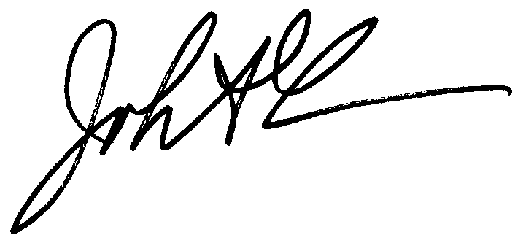

JOHN A. GIUNCO

JAG/nlc
cc: Scott Dolan – scott@arnoldhall.info
Evan Zimmerman, Esq. - ezimmerman@ghclaw.com
Denise Wegryniak – dwegryniak@ghclaw.com

Docs #4066368-v1

